Software Requirements Specification

Website Redesign & Redevelopment



For

Central Water Commission

Ministry of Jal Shakti

Version 1.0
INDEX
1. Introduction 6
2. Purpose 7
3. Definitions, Acronyms, and Abbreviations 8
4. References 9
5. Project Description 10
5.1 System Perspective 10
5.2 User Categories and Characteristics 11
5.3 Assumptions and Dependencies 11
6. Site Map 12
6.1 Admin Modules 12
6.2 Main Menu 14
6.3 Right Navigation 18
6.4 Left Navigation 19
6.5 Header 19
6.6 Footer 19
6.7 Home Page 20
6.8 About Us 20
6.9 Organogram 21
6.10 Water Info 21
6.11 Activities 22
6.12 Portals 23
6.13 Publications 24
6.14 Dashboard 25
6.15 Dam Safety Act, 2021 25
6.16 Flood 25
6.17 Citizen Corner 26
6.18 Employee’s Corner 27
6.19 Rajbhasha Corner 28
7. Business Requirements 29
7.1 Admin Module 29
7.1.1 Login - CWC_UC_001 29
7.1.2 Content Uploader - CWC_UC_002 30
7.1.3 Content Approver - CWC_UC_003 33
7.1.4 Content Publisher - CWC_UC_004 35
7.1.5 Microsite Management - CWC_UC_005 36
7.1.6 User Management - CWC_UC_006 38
7.1.7 Photo/Video Management - CWC_UC_007 41
7.1.8 Role and Permission Management - CWC_UC_008 43
7.2 Main Menu 45
7.2.1 Home – CWC_UC_09 45
7.3 Content Page 47
7.3.1 Inner Pages – CWC_UC_10 47
7.4 Microsites Management 49
7.4.1 Pages Management – CWC_UC_11 49
8. Non-Functional Requirements 52
9. Third-Party Integration 53
9.1 Email Integration 53
9.2 E-Office Integration 54
9.3 Bio-data portal Integration 54
9.4 E-Sign Integration 54
9.5 Dashboard APIs 54
10. Security 54
10.1 Secure Data Transmission 54
10.2 Security Standards 54
10.2.1 Storing Passwords: 55
10.2.2 Authenticating Users: 55
10.2.3 Protecting Routes: 55
10.2.4 HTTP Basic Authentication: 56
10.2.5 Password Reminders & Reset: 56
10.2.6 Encryption: 56
10.2.7 Authentication Drivers: 56
10.3 Website Security 56
10.3.1 Injection 57
10.3.2 Broken Authentication and Session Management 57
10.3.3 Sensitive Data Exposure 57
10.3.4 XML External Entity 58
10.3.5 Broken Access Control 58
10.3.6 Security Misconfiguration 58
10.3.7 Cross-Site Scripting 58
10.3.8 Insecure deserialization 58
10.3.9 Using Components with Known Vulnerabilities 58
10.3.10 Insufficient Logging and Monitoring 59
11. Architecture Overview 60
11.1 Technology 60
11.2 Website Architecture (Drupal) 60
11.3 Screen Layouts 61
11.3.1 Home Page Layout 61
11.3.2 Inner Page Layout 61
11.3.3 Form Layout 61
11.3.4 Profile Page 61
11.4 Database Architecture 61
11.4.1 Core Tables Grouped by Purpose 61
11.4.1.1 Content & Entities 62
11.4.1.2 Configuration & Structure 62
11.4.1.3 Access & Permissions 62
11.4.1.4 Field API Tables 62
11.4.1.5 Performance & Caching 63
11.4.1.6 Logging & Watchdog 63
11.5 Deployment Architecture 63
12. Data Migration 64
12.1 Data Migration Process 64
12.1.1 Scope 64
12.1.2 Data Mapping 64
12.1.3 Option Selection 64
12.1.4 Migration 64
12.1.5 Validation 65
12.2 Data Validation Process 65
12.2.1 Data Integrity 65
12.2.2 Data Correctness 65
12.2.3 Zero Data Loss 65
12.2.4 Proper Functioning of Application 65
12.2.5 Performance Optimization 65
13. Deployment Environment 66
13.1 Development Environment 66
13.2 Staging / Test Environment 66
13.3 Production Environment 66
14. Escalation Matrix 67
15. Common Functionalities 68
15.1 System Administration 68
15.2 Role Based Access 68
15.3 Dashboards 68
15.4 SMS and Email 68
15.5 Trap / Audit Trail 68
15.6 Logs 69
15.7 Secure Data Transmission 69
15.8 Security 69
15.8.1 Security Standards 69
15.8.1.1 Storing Passwords: 70
15.8.1.2 Authenticating Users: 70
15.8.1.3 Protecting Routes: 70
15.8.1.4 HTTP Basic Authentication: 71
15.8.1.5 Password Reminders & Reset: 71
15.8.1.6 Encryption: 71
15.8.1.7 Authentication Drivers: 71
15.8.2 Application Security 72
15.8.2.1 Injection 72
15.8.2.2 Broken Authentication and Session Management 72
15.8.2.3 Sensitive Data Exposure 73
15.8.2.4 XML External Entity 73
15.8.2.5 Broken Access Control 73
15.8.2.6 Security Misconfiguration 73
15.8.2.7 Cross-Site Scripting 73
15.8.2.8 Insecure deserialization 73
15.8.2.9 Using Components with Known Vulnerabilities 74
15.8.2.10 Insufficient Logging and Monitoring 74
15.9 Testing 74
15.10 Training 74
16. Sign-Off 75
16.1 Project Acceptance Criteria 75
16.2 Project Milestone 75
16.3 Document Sign-Off 75
17. Annexure 76
17.1 Annexure A: References 76
17.2 Annexure B: Changes/Suggestion 76

Revision History
Version | Date  (DD/MM/YYYY) | Author | Reviewer | Approver | Reason for Change
1.0 |  | Shailendra |  |  | Initial Version

Introduction
Central Water Commission is a premier Technical Organization of India in the field of Water Resources and is presently functioning as an attached office of the Ministry of Jal Shakti, Department of Water Resources, River Development and Ganga Rejuvenation, Government of India. The Commission is entrusted with the general responsibilities of initiating, coordinating and furthering in consultation of the State Governments concerned, schemes for control, conservation and utilization of water resources throughout the country, for purpose of Flood Control, Irrigation, Navigation, Drinking Water Supply and Water Power Development. It also undertakes the investigations, construction and execution of any such schemes as required.

Central Water Commission CWC is headed by a Chairman, with the status of Ex-Officio Secretary to the Government of India. The work of the Commission is divided among 3 wings namely, Designs and Research (D&R) Wing, River Management (RM) Wing and Water Planning and Projects (WP&P) Wing. Each wing is placed under the charge of a full-time Member with the status of Ex-Officio Additional Secretary to the Government of India and comprising of number of Organizations responsible for the disposal of tasks and duties falling within their assigned scope of functions.

Purpose
The purpose of the document is to collect and analyze all assorted ideas that have come up to define the system, its requirements with respect to consumers. Also, we shall predict and sort out how we hope this product will be used in order to gain a better understanding of the project, outline concepts that may be developed later, and document ideas that are being considered, but may be discarded as the product develops.
In short, the purpose of this SRS document is to provide a detailed overview of our software product, its parameters and goals. This document describes the project's target audience and its user interface, hardware and software requirements. It defines how our client, team and audience see the product and its functionality. Nonetheless, it helps any designer and developer to assist in software delivery lifecycle (SDLC) processes.

Definitions, Acronyms, and Abbreviations
This subsection provides the definitions of all terms, acronyms, and abbreviations required to properly interpret the Software Requirements Specification

# | Artifact | Description
1 | VSPL | Velocis System Pvt Ltd
2 | SRS | Software Requirement Specification
3 | UAT | User Acceptance Test
4 | CSS | Cascading Style Sheet
5 | XHTML | Extensible Hyper Text Markup Language
6 | UC | Use Cases
7 | CWC | Central Water Commission

References
# | Description | Reference
1 | Request for Proposal | TOR Document
2
3
4
5

Project Description
The Central Water Commission (CWC) proposes to undertake the redesign and redevelopment of its official website to deliver a modern, user-friendly, secure, and scalable digital platform for citizens and stakeholders. The revamped website will be developed with a contemporary look and feel, improved information architecture, and an enhanced user experience to ensure easy access to key services, publications, data, and departmental information.
The new CWC website will be built on an open-source technology stack with a robust and scalable Content Management System (CMS) to enable seamless content publishing, governance, and future scalability. The solution will also include the design and development of dedicated microsites to support various divisions, initiatives, campaigns, and regional offices while maintaining a consistent branding and identity aligned with CWC standards.

The platform will be developed in adherence to Government of India Guidelines for Indian Government Websites (GIGW) 3.0, ensuring compliance with mandated accessibility, usability, content standards, and security requirements. The website will be designed using a responsive layout, ensuring optimal performance across devices (mobile, tablet, desktop) and will be cross-browser and cross-platform compatible for broad accessibility.

To ensure a highly secure and quality-assured digital system, the project will include a third-party security audit, followed by STQC certification as per Government norms. The overall initiative aims to strengthen CWC’s digital presence by providing a reliable, compliant, and future-ready web ecosystem that supports efficient communication, transparency, and improved citizen engagement.

System Perspective
The proposed Central Water Commission (CWC) Website Redesign and Redevelopment is a replacement and modernization of the existing CWC web presence. The new system is not a standalone isolated application; rather, it is an enterprise web platform that integrates with multiple internal CWC systems and third-party government services.

The product is designed as a centralized digital communication and content delivery platform, serving both public users and internal CWC employees, while supporting scalability for future enhancements such as additional microsites, dashboards, and integrations.

This solution forms part of a larger digital ecosystem of CWC and Government of India IT systems, aligning with GIGW 3.0 guidelines, security standards, and certification requirements.

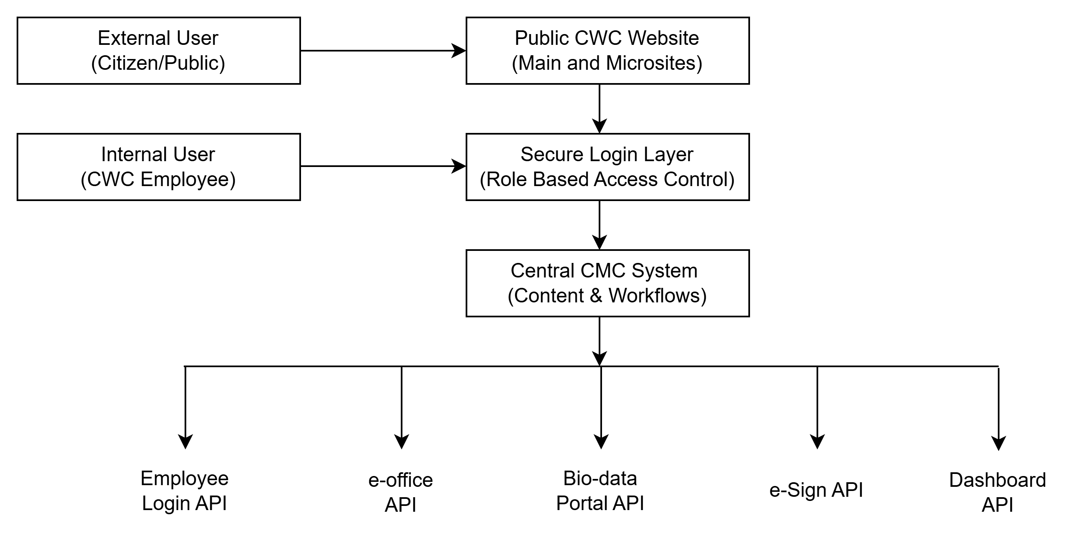

User Categories and Characteristics

# | Actors | Roles
1 | Reginal Offices | Regional office login to publish content based on the access granted
2 | HQ Administrator | View rights, based on roles and permission Granted
3 | Super Admin | Manage Sites and Microsites, Manage Roles and Permission, Manage Users, Manage Content

Assumptions and Dependencies
# | Assumptions / Dependencies | Owner
1 | Browser testing will be done on all popular web browsers like IE9.0 or higher, Firefox Mozilla 3+, Google chrome and Safari. | Velocis
2 | For development we will use:  - PHP  - DRUPAL CMS  - HTML, CSS | Velocis
3 | Testing software’s that will be used is as follows:  - W3C for XHTML validation (http://validator.w3.org/).  - W3C for CSS validation (http://jigsaw.w3.org/css-validator/)  - Wave Performance or JMeter load tester for performance testing.  - Functionality testing will be done during UAT.  - Government of India guidelines, 2009 checklist for government websites.  - Security testing  - A-Checker for accessibility testing compliance to WCAG level A. (http://achecker.ca/checker/index.php) | Velocis
4 | Acceptance testing (UAT) | Department
5 | Content for Website | Department

Site Map

Admin Modules
- Admin Panel
  - Managed CMS – to add, modify and publish content
  - User Management – to activate or deactivate users.
  - Provision to upload pdf file in admin.

- User Panel
  - User Profile: where user can edit and manage his profile.
  - Change Password, Forgot Password, Reset password link should be sent through email.
  - Role Management: Under this module Super Admin can create multiple types of roles with different – different accessibilities.

- Audit Trial: - The section will generate report and will have filters to check who has changed what and when.

- Authentication for login of
  - Content Uploader
    - The user with the mentioned roles will be able to upload and delete the CDRI website menu items content.
    - The same will not be reflected to public unless the Content Verifier and Content Publisher perform their actions.
  - Content Verifier
    - All the newly uploaded / deleted content by uploader, will be verified by the Content Verifier.
    - The content verifier will be able to approve or reject the content with remarks for Content Publisher / Content Uploader.

  - Content Publisher
    - Content once verified and approved by Content Verifier will have to be published by Content Publisher. If any modification is required, then Content Publisher will send back the same with comments to Content Verifier then Content verifier look the issue first and if he/she feel it’s required any further modification then will send back to Content Uploader for final action.
    - Once published the same will be reflected on the website for public

- Role Based Access Control (RBAC) – Content / PDF / Pages
  - Admin can manage and restrict access of content, PDF files and pages based on user role & permissions.
  - Admin can define role-wise visibility for:
  - Web pages
  - CMS content sections
  - Document/PDF downloads
  - Admin can enable/disable access for specific roles for restricted sections.

- Event Calendar Management
  - Admin can create/manage the Event Calendar module.
  - Admin can:
  - Add new events with date, time, venue, description and attachments
  - Edit or delete existing events
  - Publish/unpublish events for front-end users
  - Role-based access can be applied for internal/external events.

- Video Management (Role & Permission Based)
  - Admin can manage videos displayed on the front end based on user role and permission.
  - Admin can:
  - Upload videos or add external video links
  - Assign role-based access for videos
  - Enable/disable videos anytime
  - Categorize videos as per department/module

- Employee Login Based Content Restriction
  - Login : 1. Through Jan Parichay. 2. Direct Website Login

  - Admin can restrict the content based on employee login authentication.
  - Admin can ensure:
  - Restricted content is visible only after employee login
  - Public users cannot view internal content links/pages
  - Access permissions are mapped with employee roles

- Microsite Content Management
  - Admin can manage content for microsites under the main portal.
  - Admin can provide access to respective Microsite Admin Users to manage their microsite content.
  - Admin can:
  - Create and configure microsite pages/menus
  - Assign microsite admin roles
  - Restrict microsite sections to specific roles/users
  - Monitor and control microsite publishing

- Comment Moderation – Jalansh Magazine
  - Admin can manage comments posted by internal users on the Jalansh Magazine.
  - Admin can:
    - Approve/reject/delete comments
    - Hide inappropriate comments
    - Restrict comment posting permissions by role
    - Block/disable commenting for specific posts if required
- GIS Map Module

- Interactive Site, Basin and Sub-Basin Mapping
- Open Map in New Browser Tab

- Profile Repository

- Centralized Official Photograph Repository for Website and Microsites

- Enterprise Search
- Global Search Across Portal
- Advanced Search and Filters
- PDF/A Metadata Search
- Optimized Search Performance

- Organogram Module
- Interactive Organization Hierarchy
- Single View Navigation Structure

Main Menu
- Home
- About Us
  - Citizen Charter
  - Central Water Engineering Service (CWES)
  - Mission Statement
  - Organizational Chart
  - Profile of CWES
  - Profile of Chairman/Members
    - Chairman
    - Members
  - Who is who
- Organogram
  - CWC Organogram
  - Design & Research Wing (D&R)
  - Human Resource Management Unit
  - National Water Academy
  - River Management Wing (RM)
  - Water Planning and Projects Wing (WP & P)
- Water Info
  - Hydrological Data
  - Glacial Lakes/Water Bodies In Himalayan Region
  - Information for Kids
  - National Register of Large Dams
  - Project Hydrology
  - Reservoir Level & Storage Bulletin
  - Updation of Live Storage Capacity
  - Water Quality Information
- Activities
  - AIBP Projects
  - Capacity Building
  - Core Activities
  - Dispute Resolution
  - Flood Forecasting
  - FM Projects
  - FPARP
  - Hydro-Meteorological Observation
  - Monitoring
  - Project Appraisal
  - Recent Initiatives
    - DRIP (on mouse hover, Dam Rehabilitation & Improvement Projects)
    - GLOF (on mouse hover, Glacial Lake Outburst Flood)
    - WRIS (on mouse hover, India-India Water Resource Information System)
    - NHP (on mouse hover, National Hydrology Projects)
    - River Basin Planning
    - Water Resource Estimation
  - Research
  - Reservoir Monitoring
  - Water Quality
- Portals
  - CPDAC-Old Website
  - CWC-MIS of Water Resources Projects
  - Classified Data Release Portal
  - Water Information Management System
  - Dam Health And Rehabilitation Monitoring Application
  - Digital Archives For Engineering Drawings
  - Watershed Atlas Released Under India WRIS
  - Disaster Services By NRSC
  - River Basin Atlas Released Under India WRIS
  - e-PAMS
  - Flood Forecast
  - Reservoir Storage Monitoring System
- Publications
  - Annual Reports
  - Bhagirath
  - Hydrological Science Journal
  - Subscribed Irrigation And Drainage Journal
  - Jalansh - News Letter
  - Internal Glossary Of CWC (English - Hindi)
  - Others
  - Parliament Questions
  - e-JOURNALS
  - Water Quality Report
  - Water Year Books
  - Meta Data Books
  - Ebook
- Dashboard
- Dam Safety Act, 2021
  - Gazette Notifications
  - Documentary
  - Presentations On DSA, 2021
  - National Committee On Dam Safety (NCDS)
  - National Dam Safety Authority (NDSA)
  - Empanelment Of Dam Safety Experts (NDSA)
  - National Register For Specified Dams
- Flood
  - Flood Forecast
  - 7 Day Flood Advisory
  - FloodWatch India App Download
- Citizen Corner
  - CPP Portal
  - Tenders
  - Grievance
  - Media Cell
  - Online Museum
  - Photo Gallery
    - Videos
  - Right to Information
  - Recruitment
  - SOP for Flood Forecasting - April 2025
  - Vigilance
  - STQC Certificate For Website
- Employee Corner
  - APAR Management System
  - Archives Orders and Circulars
  - Bio-Data Information System
  - Orders And Circulars
  - CWC Administrative News Bulletins
  - Circulars - Old Website
  - Civil List
  - Content Management Role Matrix
  - Cyber Security
  - Forms & Proformas
  - eHRMS ( Manav Sampada )
  - CWC Library (E-Granthalaya)
  - Employees Of CWC Retiring In Next 15 Months
  - e-Office Implementation at CWC
  - Inventory Management System
  - FAQ's On E-Office, Sparrow Etc
  - News Clipping
  - MTNL Telephone List
  - Pension Monitoring System
  - Performance Monitoring System
  - Parliamentary Matter
  - Recruitment Rules
  - Seniority List
  - Software Resources
  - Old CWC Website
  - Work Charged Establishment Matter
- Rajbhasha Corner

Main Menu for Microsites:

      - About Us
  - Introduction
  - Organogram
  - Who’s Who
  - Telephone Directory
- Activities
  - Hydrological Observation
  - Flood Forecasting
  - Monitoring of Projects
  - Water Quality Monitoring
  - CMIS
  - Morphological Survey
  - Survey & Investigation
  - Reservoir Storage Monitoring
- Publications
  - Year Books
  - Monitoring Reports
  - Regional Magazines
  - Compendiums
  - Site Database (PPT)
- Dashboard
  - Monitoring Projects Dashboard
  - DRIP Dashboard
  - FF Dashboard
- Citizen Corner
  - Tenders
  - Grievance
  - RTI
  - Self-Disclosure of Tours
  - IEC Activities

Right Navigation
NA

Left Navigation
NA

Header
- Contact Us: Page will open showing Contact Details

- FAQ: Page will open with Frequently Asked Question and Answer

- Feedback: Feedback form will open

- Skip to Main Content: Skip to main content link allows user to easily bypass the banner, etc and directly go to content part of the page.

- Screen Reader Access: All information on this website is accessible to people with disabilities. For example, a user with visual disability can access this website using assistive technologies, such as screen readers and magnifiers. The link provide access to download tools that can be used for this purpose.

- Font Size Selection (A- A A+): These links provide the facility to decrease or increase the font size of the website.

- Language Selection: User can select Language to browse the website using this link.

- Login Button: For admin to Login to Website

Footer
- Important Links
- External Links
- Contact Information
- Terms & Conditions
- Privacy Policy
- Copyright Policy
- Hyperlinking Policy
- Accessibility Statement
- Visitor Count

Home Page
- Banner
- What’s New Section
- Minister, Chairman Profile
- Functional Domain
- Map indicating Sites
- Search
- Social Media Links
  - Facebook
  - Twitter
  - You Tube

About Us
- Citizen Charter
  - Informative page with content.
- Central Water Engineering Service (CWES)
  - Informative page with content.
- Mission Statement
  - Informative page with content displaying mission statement.
- Organizational Chart
  - Showing Organizational Chart
  - Downloadable PDF
- Profile of CWES
  - Informative pages showing Profile of Central Water Engineering Service (CWES)
- Profile of Chairman/Members
  - Chairman
    - Chairman Profile Details
  - Members
    - Member (D&R)
      - Member profile details
    - Member (RM)
      - Member profile details
    - Member (WP&P)
      - Member profile details
- Who is who
  - Detail of profiles along with (Categorized based on wing)
    - Designation
    - Name
    - Office Address
    - Phone
    - Email

Organogram
- Organogram
  - Informative page with content.
  - Link to open CWC Organogram PDF
- CWC Organogram
  - Organogram detail
- Design And Research Wing
  - Informative page with content
  - Key to abbreviations & Description
- Human Resources Management Wing
  - Informative page with content.
- National Water Academy
  - Informative page with content.
- River Management Wing
  - Informative page with content
- Water Planning and Projects Wing
  - Informative page with content

Water Info
- Water Info
  - Informative page with content
  - Internal Pages links
- Hydrological Data
  - Informative page with content
  - Links for PDF
- Glacial Lakes/Water Bodies in Himalayan Region
  - Informative page with content
  - Report on Monitoring of Glacial Lakes & Water Bodies in the Himalayan Region of Indian River Basins (PDF links)
  - Special Reports (PDF links)
- Information for Kids
  - Informative pages with images and text
  - Interlinking of the pages
- National Register of Large Dams
  - PDF link
- Project Hydrology
  - List of Documents
- Reservoir Level & Storage Bulletin
  - List of PDF files
- Updation of Live Storage Capacity
  - Informative page with content
- Water Quality Information
  - List of PDF documents

Activities
      - AIBP Projects
  - Informative page with content
      - Capacity Building
- Informative page with content
      - Core Activities
        - Informative page with content
      - Dispute Resolution
        - Informative page with content
        - PDF file links
      - Flood Forecasting
        - Informative page with content
        - External Links
      - FM Projects
        - Informative page with content
        - PDF links
      - FPARP
        - Informative page with content
        - PDF file links
      - Hydro-Meteorological Observation
        - Informative page with content
        - PDF file links
      - Monitoring
        - Informative page with content
      - Project Appraisal
        - Informative page with content
        - Links to download PDF
      - Recent Initiatives
        - DRIP (on mouse hover, Dam Rehabilitation & Improvement Projects)
          - Informative page with content
        - GLOF (on mouse hover, Glacial Lake Outburst Flood)
          - Informative page with content
          - PDF links
- WRIS (on mouse hover, India-India Water Resource Information System)
  - Informative page with content
  - Internal Page links
- NHP (on mouse hover, National Hydrology Projects)
  - Informative page with content
  - PDF links
  - External links
- River Basin Planning
  - Informative page with content
- Water Resource Estimation
  - Informative page with content
  - PDF links
      - Research
        - Informative page with content
        - PDF links
      - Reservoir Monitoring
        - Informative page with content
      - Water Quality
        - Informative page with content

Portals
- CPDAC-Old Website
  - External Website Link (connect to microsite)
- CWC-MIS of Water Resources Projects
  - Link to home screen
- Classified Data Release Portal
  - Redirect to cdrc website
- Water Information Management System
  - Redirect to external link
- Dam Health And Rehabilitation Monitoring Application
  - Redirect to external link
- Digital Archives For Engineering Drawings
  - Redirect on home screen
- Watershed Atlas Released Under India WRIS
  - External link
- Disaster Services By NRSC
  - External link
- River Basin Atlas Released Under India WRIS
  - External link
- e-PAMS
  - External links
- Flood Forecast
  - External link
- Reservoir Storage Monitoring System
  - External link

Publications
Publication tab should open new page with list of PDF file. There will search option to search any PDF by title and PDF files should be downloadable.

- Annual Reports
  - Downloadable PDF files
- Bhagirath
  - Redirect on Home Screen
- Hydrological Science Journal
  - Redirect on external link
- Subscribed Irrigation And Drainage Journal
  - Redirect on external link
- Jalansh - News Letter
  - List of downloadable PDF file
  - Search
- Internal Glossary Of CWC (English - Hindi)
  - Informative page
- Others
  - List of downloadable pdf file
  - Search
- Parliament Questions
  - Downloadable pdf files
- e-JOURNALS
  - List of downloadable pdf files
- Water Quality Report
  - List of downloadable pdf files
- Water Year Books
  - Yearly based files available for download
- Meta Data Books
  - Yearly based files available for download
- Ebook
  - Ebook link for PDF

Dashboard
This page will have other dashboard links.

Dam Safety Act, 2021
This page will have text-based information

- Gazette Notifications
  - List of pdf files to download
- Documentary
  - List of pdf files to download
- Presentations On DSA, 2021
  - List of pdf files to download
- National Committee On Dam Safety (NCDS)
  - List of pdf files to download
- National Dam Safety Authority (NDSA)
  - List of pdf files to download
- Empanelment Of Dam Safety Experts (NDSA)
  - List of pdf files to download
- National Register For Specified Dams
  - List of pdf files to download

Flood
Flood page will have text-based information.

- Flood Forecast
  - External link
- 7 Day Flood Advisory
  - External link
- FloodWatch India App Download
  - No content available for this section.

Citizen Corner
- CPP Portal
  - External link
- Tenders
  - List of tenders
  - Downloadable pdf file
  - Search tender (based on reference no, title, department name and date)
- Grievance
  - View grievance officer detail
  - Lodge your grievance here (External link)
- Media Cell
  - External links to social media
- Online Museum
  - View/download list of pdf files
- Photo Gallery
This page will show list of photos
  - Videos
    - List of videos (third party embedded)
- Right to Information
  - Information of CWC in compliance to the Obligations under Section 4 (1) (b) of RTI Act' 2005
    - List of inner pages links
  - RTI reply
    - Redirect on new page having list of PDF files
      - Search file by Title, Circular/Order No., Unit Name and Issue date
- Recruitment
  - List of Recruitments
  - Downloadable pdf files
- SOP for Flood Forecasting - April 2025
  - View pdf
- Vigilance
  - Information about “The particulars of the Vigilance Officer”
- STQC Certificate For Website
  - View certificate (pdf file)

Employee’s Corner
- APAR Management System
  - Redirect on home page
- Archives Orders and Circulars
  - This page would have Archives orders and Circulars
  - There will be pdf files listed on this page
  - Search (By Title, Reference Number and Department)
- Bio-Data Information System
  - Redirect on external link
- Orders And Circulars
  - List of pdf files
  - View/download pdf
  - Search (Title, Circular/Order No, Department name, Type of document, Issued Date )
- CWC Administrative News Bulletins
  - List of News Bulletins
  - View/Download pdf documents
- Circulars - Old Website
  - Redirect on external website
- Civil List
  - List of pdf files
- Content Management Role Matrix
  - PDF file
- Cyber Security
  - PDF list to download
- Forms & Proformas
  - List of Forms
    - View Forms
    - Download Forms
  - Search
- eHRMS ( Manav Sampada )
  - External link
- CWC Library (E-Granthalaya)
  - External link
- Employees Of CWC Retiring In Next 15 Months
  - PDF file
- e-Office Implementation at CWC
  - List of particulars
    - Navigation link (external/internal)
    - PDF file
- Inventory Management System
  - External link
- FAQ's On E-Office, Sparrow Etc
  - List of FAQ (PDF files)
  - Link to view/download
- News Clipping
  - List of publications
  - View/Download pdf files
- MTNL Telephone List
  - MTNL Telephone Directory (pdf)
- Pension Monitoring System
  - Link to Home Page
- Performance Monitoring System
  - Link to home page
- Parliamentary Matter
  - Matter list
  - PDF file to view/download
- Recruitment Rules
  - List of Cadre Post
  - Downloadable PDF
- Seniority List
  - List of Final Seniority (pdf files)
  - List of Draft Seniority (pdf files)
- Software Resources
  - List of software
  - Link to download
- Old CWC Website
  - External link
- Work Charged Establishment Matter
  - List of file (pdf files)

Rajbhasha Corner
This page will have list of pdf files to view/download.

Organization
Organization section will have two categories:
      - Headquarters
This section will redirect to the headquarter microsite. Headquarter microsite will be managed through admin panel based on the role and permission.

      - Regional Offices
This section will have list of regional offices linked to the microsites. Selecting any regional office will redirect t to the respective microsite. Microsites will be managed through admin panel based on the roles and permission.

Business Requirements

Admin Module

Login - CWC_UC_001
- Objective:
This Module is used to login into the website by giving authentic user and password. After successful login user will redirected to his dashboard as per his role.

- Use Case ID: CWC_UC_001
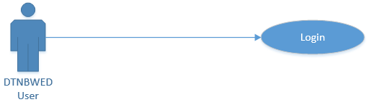
- Flow Diagram: CWC_PF_001
- Process Flow:
Header | Description
Primary Actor: | Super Admin, Uploader, Verifier, Publisher
Trigger: | On Click of Login Button / Link
Basic Flow: | - User enters User Id & Password  - User enters Captcha Code  - Click on Login button  - System will check the User role  - Website admin panel will open as per user role
Alternative Flow: | NA
Pre-Conditions: | - Internet connection should be available.  - User should have User Id and Password System.
Post-Conditions: | - System validates entered credentials  - If wrong credentials or captcha, then allow show error message  - If Correct, then role-based admin panel will be open of the website.
Business Rule: | - The website modules will be displayed as per the role of the user  - Captcha will be generated on page load
- Data Definition:
  - Basic Details:
# | Field Name | Display Type | Datatype | Mandatory  (M) | Size | Rules
 | Login Id | Textbox | Alphanumeric | M | 160 | Valid email format only
 | Password | Textbox | Alphanumeric | M | Min 8, Max 16 | Minimum 8 characters (recommended 10–12)  Must contain at least 1 uppercase letter (A–Z)  Must contain at least 1 lowercase letter (a–z)  Must contain at least 1 number (0–9)  Must contain at least 1 special character (e.g., @ # $ % & * !)  Must not contain spaces  Must not repeat same character more than 3 times (e.g., aaaa)
 | Captcha | Textbox | Alphanumeric | M | 5 | Autogenerated 5 digit alphanumeric combination
 | Login | Button |  |  |  | Validate all the required fields.  Navigate to dashboard after login

Content Uploader - CWC_UC_002
- Objective:
This will describe the Content Uploader use case.

- Use Case ID: CWC_UC_002
- Flow Diagram: CWC_PF_002

- Process Flow:
Header | Description
Primary Actor: | Super Admin, Uploader, Verifier, Publisher
Trigger: | On Click
Basic Flow: | - Click on different options available (sitemap) like  - Home  - Public Notice  - Tenders and other informative page etc.  - Click on any of the option / sub options and perform add, edit or delete operations  - Click on save button
Alternative Flow: | NA
Pre-Conditions: | - User should be logged in.  - User should have permission for Uploader role.
Post-Conditions: | - See the edited content how it will look on the public domain.  - The same will be forwarded to Approver.
Business Rule: | - Content Uploader can add/edit/delete the uploaded content  - Content uploader can upload/delete pdf files.
- Data Definition:
  - Basic Details:
Content Management:
# | Field Name | Display Type | Datatype | Mandatory  (M) | Size | Rules
 | Title | Textbox | Alphanumeric | M | 256
 | Body | CK Editor | Character | M | 1024
 | Upload file | Upload | button |  |  | Should allow to upload pdf files.  Should allow multiple file uploads  Should ask file name (non-mandatory), if not provided, default file name will be picked.  Should ask for other details (as per requirement)  Title  Reference Number  Department Name  Last date of submission (for Tenders)
 | Created By | Textbox | Alphanumeric | M | 256 | Should automatically pick the details from logged in user details.
 | Created On | Calendar | Date Time | M | 256 | Should automatically pick the created date.
 | Status | Dropdown | Character | M | 256 | Draft, Verified, Published, Return
 | Save | Button |  | M |  | Validates the field details  Saved for approver verification.

  - Basic Details:
File (PDF) Management:
# | Field Name | Display Type | Datatype | Mandatory  (M) | Size | Rules
 | Title | Textbox | Alphanumeric | M | 256
 | Reference Number | CK Editor | Character | O
 | Department Name |  |  | O
 | Particular Name |  |  | O
 | Created By | Textbox | Alphanumeric | M | 256
 | Created On | Calendar | Date Time | M | 256
 | Status | Dropdown | Character | M | 256 | Draft, Verified, Published, Return
 | Save | Button |  | M

Content Approver - CWC_UC_003
- Objective:
This module is to describe the process of Content Approval.

- Use Case ID: CWC_UC_003
- Flow Chart: CWC_PF_003

- Process Flow:
Header | Description
Primary Actor: | Super Admin, Verifier, Publisher
Trigger: | On Click
Basic Flow: | - Content approver will be able to see the newly uploaded content of the website.  - Content approver can approve or reject the uploaded content with remarks  - Click on any of the option / sub options and perform Approve or Reject operations  - If user rejects the content, User will enter remarks  - Click on save button
Alternative Flow: | NA
Pre-Conditions: | - User should be logged in.  - User should have permission for Approver / Verifier role.
Post-Conditions: | - User Approves or Reject the content.  - The same will be forwarded to Uploader / Publisher, if approved  - The same will be sent back to uploader, if rejected
Business Rule: | - Approved content is forwarded to Content Publisher for further necessary action.  - Rejected content forward to content uploader to take the suggested changes.
- Data Definition:
  - Basic Details:
# | Field Name | Display Type | Datatype | Mandatory  (M) | Size | Rules
 | Title | Textbox | Alphanumeric | M | 256
 | Body | CK Editor | Character | M | 1024
 | Upload file | Upload | button |  |  | Should allow to upload pdf files.  Should allow multiple file uploads  Should ask file name (non-mandatory), if not provided, default file name will be picked.  Should ask for other details (as per requirement)  Title  Reference Number  Department Name  Last date of submission (for Tenders)
 | Created By | Textbox | Alphanumeric | M | 256 | Should automatically pick the details from logged in user details.
 | Created On | Calendar | Date Time | M | 256 | Should automatically pick the created date.
 | Status | Dropdown | Character | M | 256 | Draft, Verified, Published, Return
 | Save | Button |  | M |  | Validates the field details  Saved for approver verification.

Content Publisher - CWC_UC_004
- Objective:
This module is to describe the process of content publishing on the website.

- Use Case ID: CWC_UC_004
- Flow Chart: CWC_PF_004

- Process Flow:
Header | Description
Primary Actor: | Super Admin, Publisher
Trigger: | On Click
Basic Flow: | - Content publisher will be able to see list of approved content of the website.  - Content publisher can publish or reject the approved content with remarks  - Click on any of the option / sub options and perform Publish or Reject operations  - If user rejects the content, User will enter remarks  - Click on save button
Alternative Flow: | NA
Pre-Conditions: | - User should be logged in.  - User should have permission of Publisher role.
Post-Conditions: | - User Publish or Reject the content.  - The Rejected will be sent back to Approver.
Business Rule: | - Published content is visible to everyone who browse the website.  - Rejected content forward to content approver for suggested changes.
- Data Definition:
  - Basic Details:
# | Field Name | Display Type | Datatype | Mandatory  (M) | Size | Rules
 | Title | Textbox | Alphanumeric | M | 256
 | Body | CK Editor | Character | M | 1024
 | Upload file | Upload | button |  |  | Should allow to upload pdf files.  Should allow multiple file uploads  Should ask file name (non-mandatory), if not provided, default file name will be picked.  Should ask for other details (as per requirement)  Title  Reference Number  Department Name  Last date of submission (for Tenders)
 | Created By | Textbox | Alphanumeric | M | 256 | Should automatically pick the details from logged in user details.
 | Created On | Calendar | Date Time | M | 256 | Should automatically pick the created date.
 | Status | Dropdown | Character | M | 256 | Draft, Verified, Published, Return
 | Save | Button |  | M |  | Validates the field details  Saved for approver verification.

Microsite Management - CWC_UC_005
- Objective:
This module is to describe the process of microsites management.

- Use Case ID: CWC_UC_005

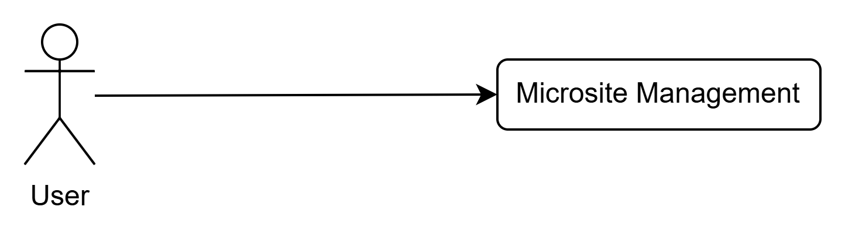

- Flow Chart: CWC_PF_005

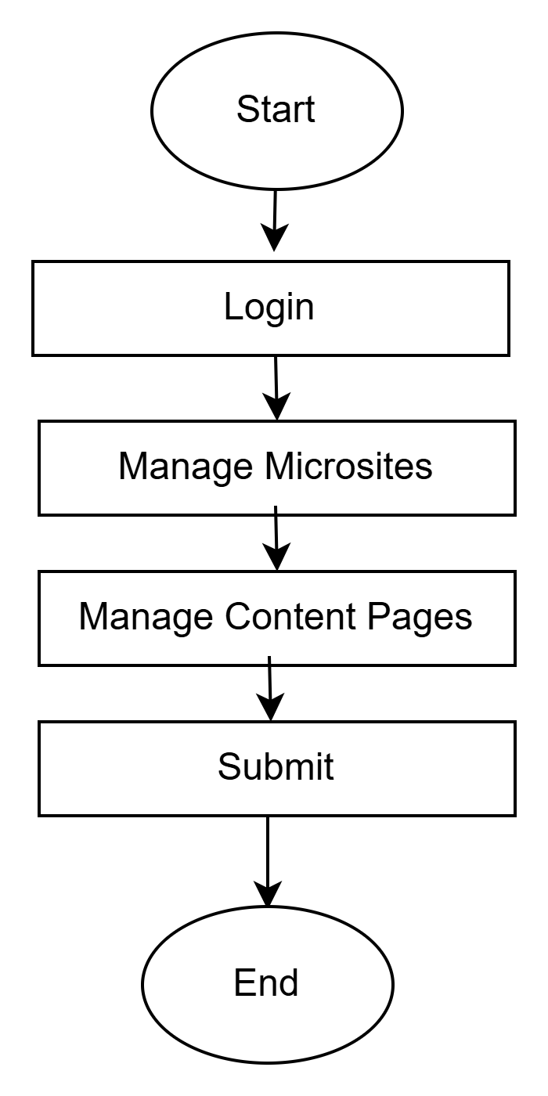

- Process Flow:
Header | Description
Primary Actor: | Super Admin / Admin / Microsite Content Manager (as per permission)
Trigger: | On click of Microsites Management menu from Admin Panel
Basic Flow: | - Admin logs into the portal using valid credentials.  - Admin navigates to Admin Panel → Microsites Management.  - System displays a list of available microsites with details such as Microsite Name, URL, Owner/Department, Status, and Last Updated Date.  - Admin clicks on Create New Microsite to add a new microsite.  - Admin enters microsite details such as Microsite Name, Microsite URL, Description, Department/Wing, Theme/Template (if applicable), and assigns role-based access permissions.  - Admin clicks Save to create the microsite.  - Admin selects a microsite from the list and clicks Manage Pages to create or manage microsite content pages.  - Admin creates a new page by entering Page Title, Page Type, Page Content, Attachments (if any), and sets visibility and permissions.  - Admin can edit existing pages, update content, and submit for publish/approval (if workflow enabled).  - Admin can deactivate a microsite or individual microsite pages when required.  - System updates the microsite content and makes it available on the front-end as per the published status and access permissions.
Alternative Flow: | NA
Pre-Conditions: | - User must be logged in.  - User must have permission for microsite management activities.  - Page templates and content components (if any) must be configured in the CMS.
Post-Conditions: | - Microsite is created successfully and available for page management.  - Content pages are created/updated and published as per workflow.  - Deactivated microsites/pages are not visible to unauthorized users or public portal.
Business Rule: | - Only authorized users can create/edit/publish/deactivate microsites and pages based on RBAC permissions.  - Microsite URL must be unique within the system.  - Each microsite page should follow content validation rules (title, mandatory fields, supported attachments).  - A deactivated microsite/page must not be accessible on the front-end portal.  - Audit logs must be maintained for all microsite and content actions (create/update/publish/deactivate).

User Management - CWC_UC_006
- Objective:
This module is to describe the process of user management on the website.

- Use Case ID: CWC_UC_006
- Flow Chart: CWC_PF_006

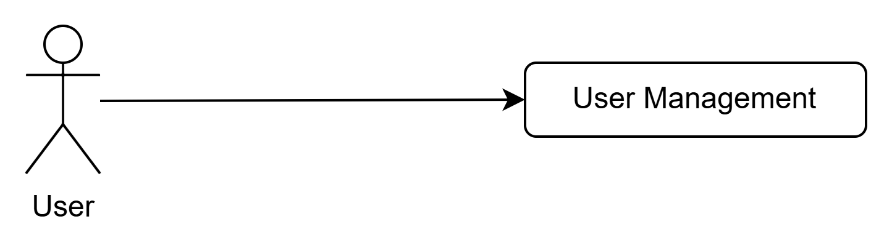

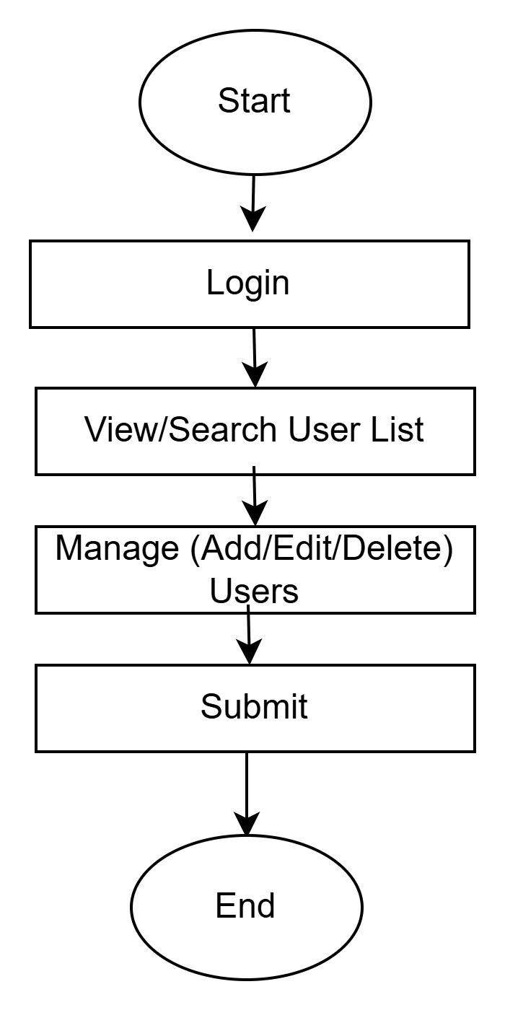

- Process Flow:
Header | Description
Primary Actor: | Super Admin/Admin
Trigger: | On click of User Management menu from Admin Panel
Basic Flow: | - Admin logs into the system using valid credentials.  - Admin navigates to Admin Panel → User Management.  - System displays the list of users with basic details and current status (Active/Inactive).  - Admin can click on Create New User to add a new user in the system.  - Admin enters user details such as Name, Mobile Number, Email ID, Role, and assigns credentials.  - Admin clicks on Save to create the user.  - User should receive an email with User ID and Password, once user is created.  - Admin can search/select any existing user from the list and click on Edit to modify user details.  - Admin updates the required details and clicks on Update/Save.  - Admin can deactivate a user by clicking on Deactivate against the selected user.  - System updates the user status as Inactive and restricts login access for that user.
Alternative Flow: | NA
Pre-Conditions: | - Admin user must be logged in.  - Admin user must have User Management permission.
Post-Conditions: | - New user is successfully created in the system.  - Existing user details are updated successfully.  - Deactivated user is restricted from system access.
Business Rule: | - Only Admin/Super Admin can create, edit, or deactivate users.  - User Email ID / Mobile Number must be unique in the system.  - Deactivated users cannot log in until reactivated (if applicable).  - Password policies must be followed as per security rules.
- Data Definition:
  - Basic Details:
# | Field Name | Display Type | Datatype | Mandatory  (M) | Size | Rules
 | Title | Textbox | Alphanumeric | M | 256
 | Full Name | Textbox | Alphanumeric | M | 100 | Only alphabets and spaces allowed
 | Employee ID / User ID | Textbox | Alphanumeric | O | 50 | Unique identifier (if applicable)
 | Email ID | Textbox | Email | M | 100 | Must be valid & unique
 | Password | Textbox |  | M | 16 | Should accept alphanumeric characters only,  Should contain one special character
 | Confirm Password | Textbox |  | M | 16 | Should accept alphanumeric characters only,  Should contain one special character
 | Mobile Number | Textbox | Numeric | M | 10 | Must be 10 digits & unique
 | Role | Dropdown | Character | M | 50 | Admin / Approver / Publisher / Viewer etc.

Photo/Video Management - CWC_UC_007
- Objective:
This module is to describe the process of photo/video management on the website.

- Use Case ID: CWC_UC_007

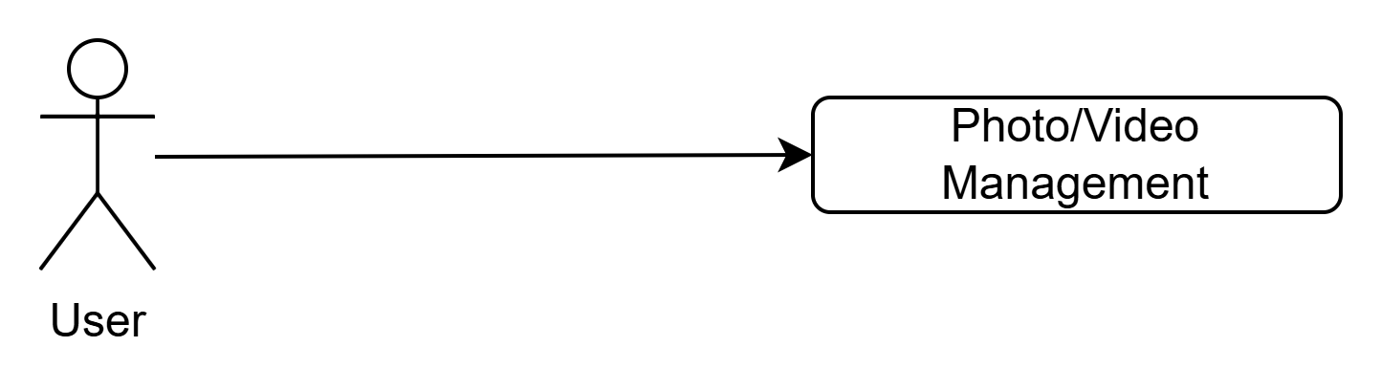

- Flow Chart: CWC_PF_007

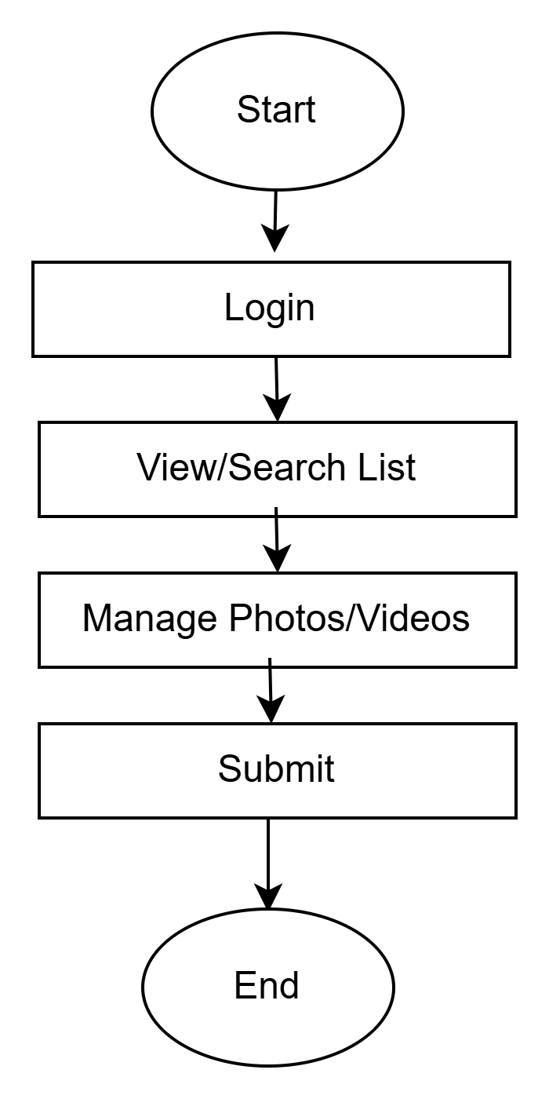

- Process Flow:
Header | Description
Primary Actor: | Super Admin / Admin / Content Manager (as per permission)
Trigger: | On click of Photo/Video Management menu from Admin Panel
Basic Flow: | - Admin logs into the system using valid credentials.  - Admin navigates to Admin Panel → Photo/Video Management.  - System displays a list/grid of uploaded media with details such as title, type (Photo/Video), category, upload date, and status (Active/Inactive).  - Admin clicks on Upload Media to add new photo/video content.  - Admin selects the media type (Photo/Video) and uploads the file(s). There will be option to add link/embedded code for third party embedded video.  - Admin enters metadata such as Title, Description, Category, Tags, and Visibility/Permissions.  - Admin sets the media status as Active and clicks Save/Publish.  - Admin can search/select any existing media and click Edit to modify details, replace file, or update permissions.  - Admin can deactivate media by clicking Deactivate to restrict it from being visible to end users.  - System updates the media listing and reflects the latest status on the front-end as per permissions.
Alternative Flow: | NA
Pre-Conditions: | - Admin must be logged in.  - User must have permission to upload/manage media content.  - Supported file formats and max upload size should be configured in system settings.
Post-Conditions: | - Photo/video content is successfully uploaded and stored.  - Media metadata is saved and visible as per assigned permissions.  - Edited media details are updated successfully.  - Deactivated media becomes unavailable for end users.
Business Rule: | - Only authorized users (Admin/Content Manager) can upload/edit/deactivate media.  - Media visibility must follow role-based access control (RBAC).  - Videos may be stored as file uploads or embedded via URL (YouTube) as per configuration.  - Deactivated media should not appear on the public portal.
- Data Definition:
  - Basic Details:
# | Field Name | Display Type | Datatype | Mandatory  (M) | Size | Rules
1 | Media Type | Dropdown | Character | M | 20 | Photo / Video
2 | Title | Textbox | Alphanumeric | M | 150 | Unique title recommended
3 | Description | Text Area | Character | O | 500 | Optional summary
4 | Category | Dropdown | Character | M | 100 | Category must be selected
5 | Tags / Keywords | Textbox | Character | O | 200 | Comma separated
6 | Upload Media File | File Upload | Binary | M | - | JPG/PNG for photos, MP4 for videos (configurable)
7 | Video URL (Optional) | Textbox | URL | O | 500 | If video is embedded via link
8 | Thumbnail | File Upload | Binary | O | - | Recommended for videos
9 | Visibility / Role Access | Multi-select | Character | M | 200 | Role-based visibility
10 | Publish Date | Date Picker | Date | O | - | Default = Current date
11 | Status | Dropdown | Character | M | 20 | Active / Inactive

Role and Permission Management - CWC_UC_008
- Objective:
This module is to describe the process of role and permission on the website.

- Use Case ID: CWC_UC_008
- Flow Chart: CWC_PF_008
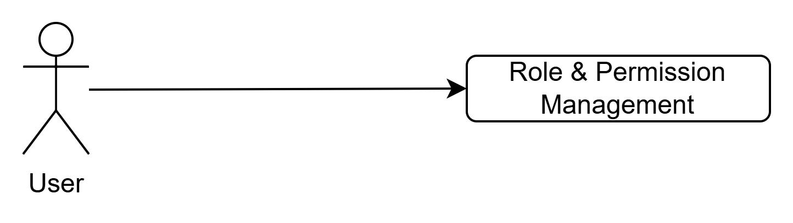

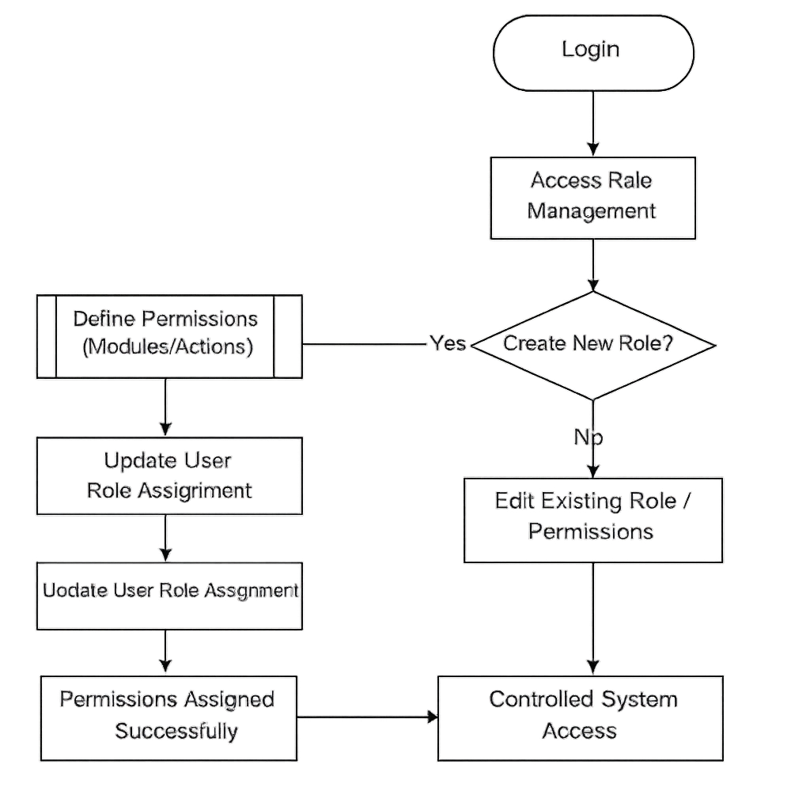

- Process Flow:
Header | Description
Primary Actor: | Super Admin / Admin / Content Manager (as per permission)
Trigger: | On click of Role Management menu from Admin Panel
Basic Flow: | - Admin logs into the system using valid credentials.  - Admin navigates to Admin Panel → Role Management.  - System displays the list of existing roles along with status (Active/Inactive).  - Admin clicks on Create New Role to add a new role.  - Admin enters role details such as Role Name, Role Description, and selects module-wise permissions (View/Create/Edit/Delete/Approve/Publish etc.).  - Admin clicks on Save to create the role.  - Admin can select any existing role and click on Edit to modify role details or permissions.  - Admin updates the details and clicks on Update/Save.  - Admin can deactivate a role by clicking on Deactivate.  - System updates the role status as Inactive, and the role cannot be assigned to new users.
Alternative Flow: | NA
Pre-Conditions: | - Admin must be logged in.  - Admin must have permission to manage roles and permissions.
Post-Conditions: | - New role is created successfully with defined permissions.  - Existing role permissions are updated successfully.  - Role is deactivated successfully (as applicable).
Business Rule: | - Only Admin/Super Admin can create, edit, or deactivate roles.  - Role Name must be unique across the system.  - Permissions should be assigned module-wise and action-wise (RBAC).  - Inactive roles cannot be assigned to users.  - If role is assigned to users, the system should prevent deletion and allow only deactivation (recommended).  - Any change in role permissions should apply immediately to mapped users.
- Data Definition:
  - Basic Details:
# | Field Name | Display Type | Datatype | Mandatory  (M) | Size | Rules
1 | Role Name | Textbox | Alphanumeric | M | 100 | Must be unique
2 | Role Description | Text Area | Character | O | 256 | Brief role purpose
3 | Permission Type | Checkbox / Multi-select | Character | M | 256 | View/Create/Edit/Delete/Approve/Publish
4 | Module Access | Checkbox Grid | Character | M | 500 | Module-wise permission mapping
5 | Status | Dropdown | Character | M | 20 | Active / Inactive
6 | Save | Button | - | M | - | Create role
7 | Update | Button | - | M | - | Update role

Main Menu

Home – CWC_UC_09
- Objective:
This module defines the home page content and information for the website.

- Use Case ID: CWC_UC_09
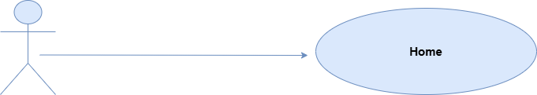

- Flow Chart: CWC_FC_09

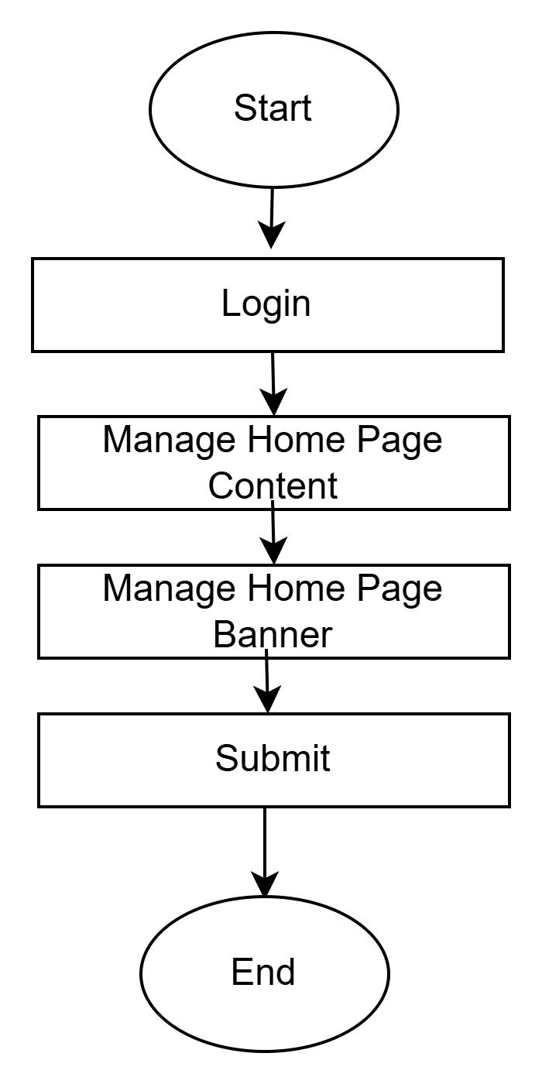

- Process Flow:
Header | Description
Primary Actor: | Super Admin/Admin, Uploader, Verifier, Publisher, Other
Trigger: | On Click on home page management
Basic Flow: | - User will be able to manage home page banner.  - User will be able to manage home page content.  - User will be able to manage sub-menu for the following menu:  - About Us  - Organogram  - Water Info  - Activities  - Portals  - Publications  - Dam Safety Act, 2021  - Flood  - Citizen Corner  - Employee Corner
Alternative Flow: | NA
Pre-Conditions: | - User should be logged in into the admin panel.  - User should have access to manage the sub-menu/pages.
Post-Conditions: | - Content will be displayed on Page.
Business Rule: | - Content Uploader can add/edit/delete the uploaded content  - Content uploader can upload/delete pdf files based on access.

Content Page

Inner Pages – CWC_UC_10
- Objective:
This module defines the content management for the informative pages.

- Use Case ID: CWC_UC_10

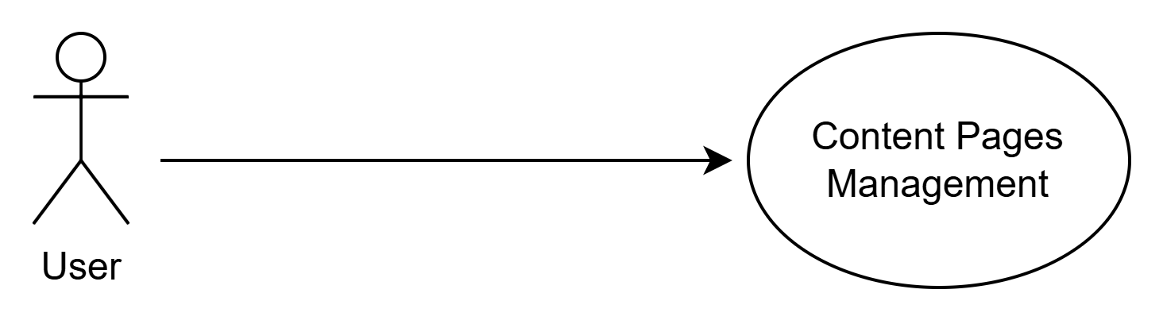

- Flow Chart: CWC_FC_10

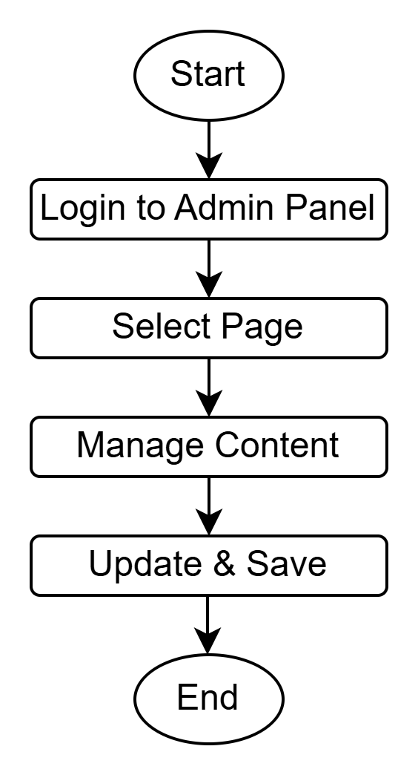

- Process Flow:
Header | Description
Primary Actor: | Super Admin / Admin / Content Manager (as per permission)
Trigger: | On Click on the Page name to manage the content
Basic Flow: | Basic Flow Details.  - Admin logs into the system using valid credentials.  - Admin navigates to Admin Panel → Informative Pages Management.  - System displays a list of existing pages with details such as Page Title, Category/Section, Publish Status, Visibility, and Last Updated Date.  - Admin clicks on Create New Page to add a new informative page.  - Admin enters page details such as Page Title, Content/Description, Category/Section, and Visibility settings.  - Admin uploads one or multiple PDF files (if applicable) and enters PDF metadata such as Document Title/Description.  - Admin assigns role-based access permissions to control who can view the page and PDF files.  - Admin saves the page as Draft or marks it as Published based on permission/workflow.  - Admin can search/select an existing page and click on Edit to update content or replace/remove attached PDF files.  - Admin can deactivate/unpublish any page or PDF file if required.  - System updates the page and documents on the front-end portal as per the latest status and permissions.
Alternative Flow: | NA
Pre-Conditions: | - User must be logged in.  - User must have permission to manage informative pages and documents.  - Allowed file formats and file size limits must be configured in the system settings.
Post-Conditions: | - Informative pages are created/updated successfully in the system.  - PDF files are uploaded and linked to the relevant pages.  - Published pages and documents are visible to end users as per assigned permissions.  - Deactivated pages/documents are not visible on the portal.
Business Rule: | - Only authorized users can create/edit/publish/deactivate informative pages and PDF files.  - PDF files must be uploaded only in supported formats (PDF) and within size limits.  - Visibility rules must follow RBAC (Public/Internal/Role-based).  - Deactivated content must not be accessible through portal search or direct URL.  - Audit trails should be maintained for all create/edit/publish/deactivate actions.
- Data Definition:
  - Basic Details:
# | Field Name | Display Type | Datatype | Mandatory  (M) | Size | Rules
1 | Page Title | Textbox | Character | M | 200 | Title must be provided
2 | Category / Section | Dropdown | Character | M | 100 | Mandatory selection
3 | Page Content | Rich Text Editor | Character | M | - | Supports formatted content
4 | Short Description | Text Area | Character | O | 500 | Optional summary
5 | PDF Upload | File Upload | Binary | O | - | Only PDF format allowed
6 | PDF Title | Textbox | Character | O | 200 | Optional for document listing
7 | PDF Description | Text Area | Character | O | 500 | Optional
8 | Multiple PDF Upload | Multi File Upload | Binary | O | - | Supports multiple documents
9 | Visibility | Dropdown | Character | M | 50 | Public / Internal / Role-based
10 | Role Access / Permissions | Multi-select | Character | O | 500 | Based on RBAC rules
11 | Publish Status | Dropdown | Character | M | 50 | Draft / Pending Approval / Published
12 | Status | Dropdown | Character | M | 20 | Active / Inactive
13 | Save Page | Button | - | M | - | Saves as draft or final
14 | Publish Page | Button | - | O | - | Only for authorized roles
15 | Edit Page | Button | - | M | - | Updates existing page
16 | Deactivate Page | Button | - | O | - | Marks page inactive
17 | Remove/Replace PDF | Button | - | O | - | Allowed for authorized roles

Microsites Management

Pages Management – CWC_UC_11
- Objective:
This module defines the pages and content management for the microsites.

- Use Case ID: CWC_UC_11

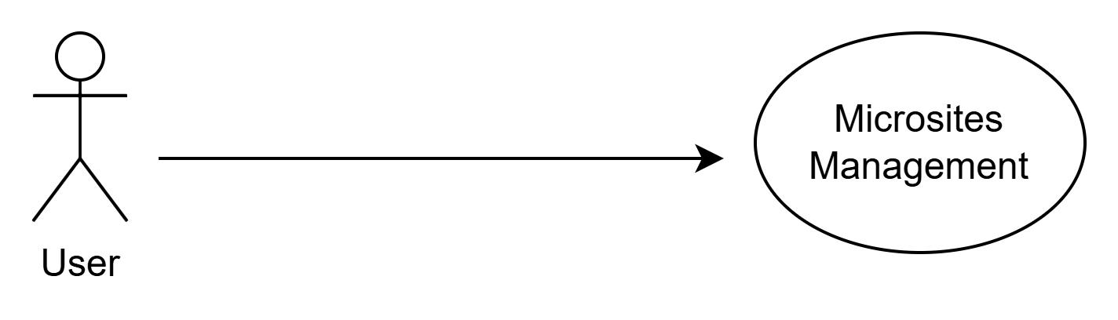

- Flow Chart: CWC_FC_11

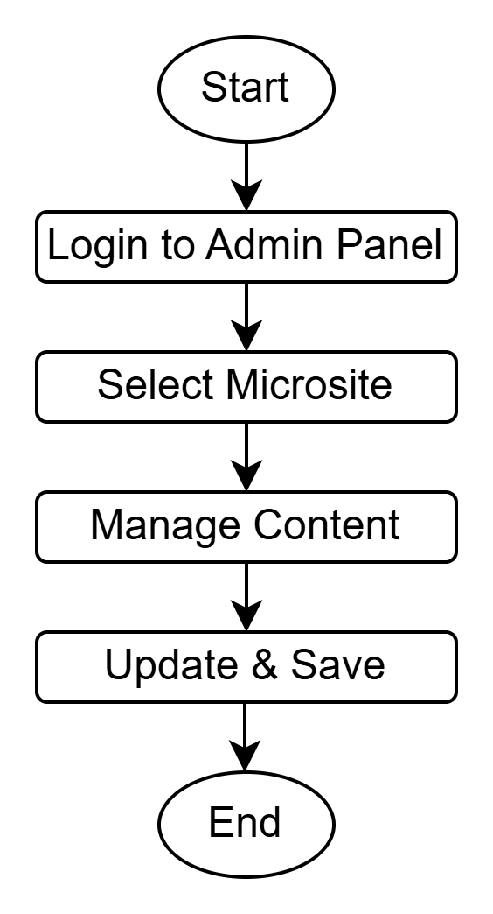

- Process Flow:
Header | Description
Primary Actor: | Super Admin / Admin / Microsite Content Manager (as per permission)
Trigger: | On click of Microsites Management menu from Admin Panel
Basic Flow: | - Admin logs into the portal using valid credentials.  - Admin navigates to Admin Panel → Microsites Management.  - System displays a list of available microsites with details such as Microsite Name, URL, Owner/Department, Status, and Last Updated Date.  - Admin enters microsite details such as Microsite Name, Microsite URL, Description, Department/Wing, Theme/Template (if applicable), and assigns role-based access permissions.  - Admin clicks Save to create the microsite.  - Admin selects a microsite from the list and clicks Manage Pages to create or manage microsite content pages.  - Admin creates a new page by entering Page Title, Page Type, Page Content, Attachments (if any), and sets visibility and permissions.  - Admin can edit existing pages, update content, and submit for publish/approval (if workflow enabled).  - Admin can deactivate a microsite or individual microsite pages when required.  - System updates the microsite content and makes it available on the front-end as per the published status and access permissions.
Alternative Flow: | NA
Pre-Conditions: | - User must be logged in.  - User must have permission for microsite management activities.  - Page templates and content components (if any) must be configured in the CMS.
Post-Conditions: | - Microsite is created successfully and available for page management.  - Content pages are created/updated and published as per workflow.  - Deactivated microsites/pages are not visible to unauthorized users or public portal.
Business Rule: | - Only authorized users can create/edit/publish/deactivate microsites and pages based on RBAC permissions.  - Microsite URL must be unique within the system.  - Each microsite page should follow content validation rules (title, mandatory fields, supported attachments).  - A deactivated microsite/page must not be accessible on the front-end portal.  - Audit logs must be maintained for all microsite and content actions (create/update/publish/deactivate).
- Data Definition:
  - Basic Details:
# | Field Name | Display Type | Datatype | Mandatory  (M) | Size | Rules
 | Title | Textbox | Alphanumeric | M | 256
- 1 | Microsite Name | Textbox | Alphanumeric | M | 150 | Must be unique
- 2 | Microsite URL / Slug | Textbox | Character | M | 150 | Unique URL identifier (no spaces)
- 3 | Description | Text Area | Character | O | 500 | Optional overview
- 4 | Department / Wing | Dropdown | Character | O | 100 | As per department structure
- 5 | Theme / Template | Dropdown | Character | O | 100 | Select predefined template
- 6 | Status | Dropdown | Character | M | 20 | Draft / Active / Inactive
- 7 | Role Access / Permissions | Multi-select / Checkbox | Character | M | 500 | Role-based content access
- 8 | Create Microsite | Button | - | M | - | Saves microsite details
- 9 | Edit Microsite | Button | - | M | - | Updates microsite details
- 10 | Deactivate Microsite | Button | - | M | - | Marks microsite inactive
- 11 | Page Title | Textbox | Character | M | 200 | Mandatory for each content page
- 12 | Page Type | Dropdown | Character | O | 50 | Static / Dynamic / Form / Gallery etc.
- 13 | Page Content | Rich Text Editor | Character | M | - | Supports formatted content
- 14 | Attachments | File Upload | Binary | O | - | PDF/Image/Doc etc. (as allowed)
- 15 | Page Visibility | Dropdown | Character | M | 50 | Public / Internal / Role-based
- 16 | Publish Status | Dropdown | Character | M | 50 | Draft / Pending Approval / Published
- 17 | Save Page | Button | - | M | - | Creates/updates a microsite page
- 18 | Publish Page | Button | - | O | - | Allowed only for authorized roles
- 19 | Deactivate Page | Button | - | O | - | Removes page from front-end

Non-Functional Requirements
# | Requirement | Description  (Details & Validation) | Priority  (E) Essential  (C) Conditional  (O) Optional
1 | Cross-browser | Cross-browser development is making a web page look and behave the same on different desktop and mobile browsers. | E
2 | Responsive Development | Responsive design is a way of developing web properties so that the device they are used on determines the way that the site will be displayed properly in all the devices like mobile, Tablet, Desktop etc in all the aspect ratio. | E
3 | Session Management | User Session should be handled properly to Ensure that sensitive information is not compromised by ensuring that it is not persistent, encrypting it, and storing it only for the duration of the need.  Some best practices to session management are Set secure/HttpOnly flags on your cookies, Generate new session cookies, Configure session cookies properly. | E
4 | Web Performance | Performance is very important aspect. Factors should be taken care during the development as Implement Gzip Compression, Optimize Image Sizes, Minify and Combine CSS, JavaScript, and HTML Files, Load JavaScript Asynchronously. | E
5

Third-Party Integration

Email Integration
Email gateway integration for sending email.

E-Office Integration
E-office integration to get data from e-office to publish on the website.

Bio-data portal Integration
Integration of bio-data portal to reflect the details about the employee on the website.

E-Sign Integration
e-sign integration to get the signature of concerned publisher on the required files/pdf

Dashboard APIs
Integration of external apis to display the required information over the dashboard.

Bhashini API
Bhashini API to translate the website content from English to Hindi languages.

Security

Secure Data Transmission
Security will be the prime thrust area and system would not allow any leakage of essential and confidential information. It will provide a secure role-based access to User’s based on their assigned access rights. Secure online data entries from stakeholders will serve as data source for all reports and would allow stakeholders to monitor the progress at every level.

Security Standards
Security audit of the application will be done for checking the OWASP from CERT-In/empaneled agencies.
- Safe to host certificate for website and application.
- Application server security
- Protection from virus/worm attacks
- Data security
- Application level security
- Free from OWASP Top 10 vulnerabilities.
Velocis will incorporate the various security standards during the application development as mentioned below

Security Standards
User Authentication
Audit Trail Management
Encryption Technique
CERT-In
3Level verification

Storing Passwords:
- Hashing A Password Using Bcrypt
- Verifying A Password Against A Hash
- Checking If A Password Needs To Be Rehashed

Authenticating Users:
- Determining If A User Is Authenticated
- Authenticating A User And "Remembering" Them
- Determining If User Authed Via Remember
- Authenticating A User With Conditions
- Accessing The Logged In User
- Validating User Credentials Without Login
- Logging A User In For A Single Request

Protecting Routes:
- CSRF Protection
- Inserting CSRF Token Into Form
- Validate The Submitted CSRF Token

HTTP Basic Authentication:
- Protecting A Route With HTTP Basic
- Setting Up A Stateless HTTP Basic Filter

Password Reminders & Reset:
- Model & Table
- Password Reminder Controller
- Password Validation

Encryption
- Encrypting A Value
- Decrypting A Value
- Setting The Cipher & Mode

Authentication Drivers:
- Database authentication drivers
- Eloquent authentication driver
- Application Security

Website Security
The following identifies each of the OWASP Top 10 Web Application Security Risks, and offers solutions and best practices to prevent or remediate them.

A6 Sensitive Data Exposure
A7 Insufficient Attack Protection
A8 Cross-Site Request Forgery (CSRF)
A9 Using Components with Known Vulnerabilities
A10 Under protected APIs
A5 Security Misconfiguration
A4 Broken Access Control
A3 Cross-Site Scripting (XSS)
A2 Broken Authentication and Session Management
A1 Injection
OWASP Web Top 10

Injection
Injection flaws, such as SQL injection, LDAP injection, and CRLF injection, occur when an attacker sends untrusted data to an interpreter that is executed as a command without proper authorization.
* Application security testing can easily detect injection flaws. Developers should use parameterized queries when coding to prevent injection flaws.

Broken Authentication and Session Management
Incorrectly configured user and session authentication could allow attackers to compromise passwords, keys, or session tokens, or take control of users’ accounts to assume their identities.
* Multi-factor authentication, such as FIDO or dedicated apps, reduces the risk of compromised accounts.

Sensitive Data Exposure
Applications and APIs that don’t properly protect sensitive data such as financial data, usernames and passwords, or health information, could enable attackers to access such information to commit fraud or steal identities.
* Encryption of data at rest and in transit can help you comply with data protection regulations.

XML External Entity
Poorly configured XML processors evaluate external entity references within XML documents. Attackers can use external entities for attacks including remote code execution, and to disclose internal files and SMB file shares.
* Static application security testing (SAST) can discover this issue by inspecting dependencies and configuration.

Broken Access Control
Improperly configured or missing restrictions on authenticated users allow them to access unauthorized functionality or data, such as accessing other users’ accounts, viewing sensitive documents, and modifying data and access rights.
* Penetration testing is essential for detecting non-functional access controls; other testing methods only detect where access controls are missing.

Security Misconfiguration
This risk refers to improper implementation of controls intended to keep application data safe, such as misconfiguration of security headers, error messages containing sensitive information (information leakage), and not patching or upgrading systems, frameworks, and components.
* Dynamic application security testing (DAST) can detect misconfigurations, such as leaky APIs.

Cross-Site Scripting
Cross-site scripting (XSS) flaws give attackers the capability to inject client-side scripts into the application, for example, to redirect users to malicious websites.
* Developer training complements security testing to help programmers prevent cross-site scripting with best coding best practices, such as encoding data and input validation.

Insecure deserialization
Insecure deserialization flaws can enable an attacker to execute code in the application remotely, tamper or delete serialized (written to disk) objects, conduct injection attacks, and elevate privileges.
* Application security tools can detect deserialization flaws but penetration testing is frequently needed to validate the problem.

Using Components with Known Vulnerabilities
Developers frequently don’t know which open source and third-party components are in their applications, making it difficult to update components when new vulnerabilities are discovered. Attackers can exploit an insecure component to take over the server or steal sensitive data.
* Software composition analysis conducted at the same time as static analysis can identify insecure versions of components.

Insufficient Logging and Monitoring
The time to detect a breach is frequently measured in weeks or months. Insufficient logging and ineffective integration with security incident response systems allow attackers to pivot to other systems and maintain persistent threats.
* Think like an attacker and use pen testing to find out if you have sufficient monitoring; examine your logs after pen testing.

Architecture Overview

Technology
Website Technology Stack

Component | Technology
Language | PHP 8.3+
Framework/Template Engine | Symfony 7
DB Support | MySQL
Frontend Themes | Olivero (frontend), Claro (admin)
JavaScript | ES6+, gradually removing jQuery
Text Editor | CKEditor 5
CLI Tooling | Drush, Symfony CLI
Templating Engine | Twig 3

Website Architecture (Drupal)

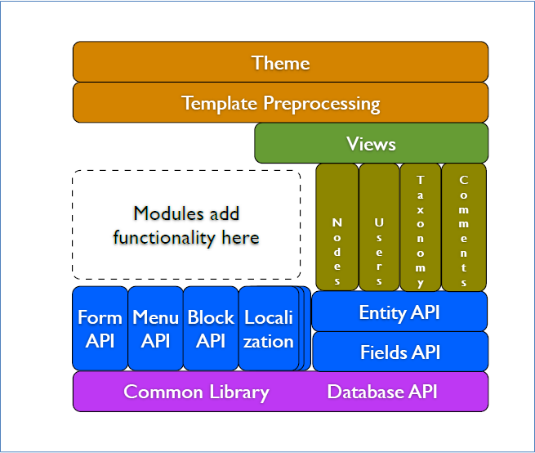
- User Interface Layer
  - Claro (Admin UI), Olivero (Frontend Theme), Responsive Design
- Front-End Layer
  - Twig 3 Templating, CKEditor 5, JavaScript (ES6+), Webpack
- Application Layer
  - Drupal Core APIs (Entity, Field, Config), Custom/Contrib Modules
- Framework Layer
  - Symfony 6.2 (Routing, Events, DI, Services)
- Backend Layer
  - PHP 8.1+, Composer, Drush CLI, PHPUnit
- Data Layer
  - MySQL/PostgreSQL/MariaDB, File System, Config Management

Screen Layouts
Lay

Home Page Layout

Inner Page Layout

Form Layout

Profile Page

Database Architecture
Drupal uses a relational database model (primarily MySQL, MariaDB, or PostgreSQL) to store:
- Content
- Configuration
- Users/Roles
- Permissions
- Cache
- Logs

Core Tables Grouped by Purpose

Content & Entities
Entity Type | Key Tables
Nodes (Content) | node, node_field_data, node_revision, node__*
Taxonomy Terms | taxonomy_term_data, taxonomy_term_field_data, taxonomy_term__*
Users | users, users_field_data, user__*
Files & Media | file_managed, media, media_field_data, media__*
Comments | comment, comment_field_data, comment__*

Configuration & Structure
Component | Key Tables
Configuration Storage | config (deprecated), YAML files in config/ directory
Menus | menu_tree, menu_link_content
Blocks | block_content, block_content__*
Views | Defined in YAML, stored in config exports

Access & Permissions
Purpose | Tables
Users | users, user__*
Roles | user__roles, role
Permissions | role_permission, user_role

Field API Tables
Purpose | Example
Base Field Storage | node_field_data, node_revision
Field Storage | node__body, node__field_image
Revisions | node_revision__body
Translations | node_field_revision, node__field_name__translation

Performance & Caching
Cache Bin | Table
Render Cache | cache_render
Dynamic Pages | cache_page
Configuration | cache_config
Entity Cache | cache_entity
Other | cache_bootstrap, cache_discovery, cache_default

Logging & Watchdog
Purpose | Table
Logging | watchdog (if syslog module is disabled)

Deployment Architecture
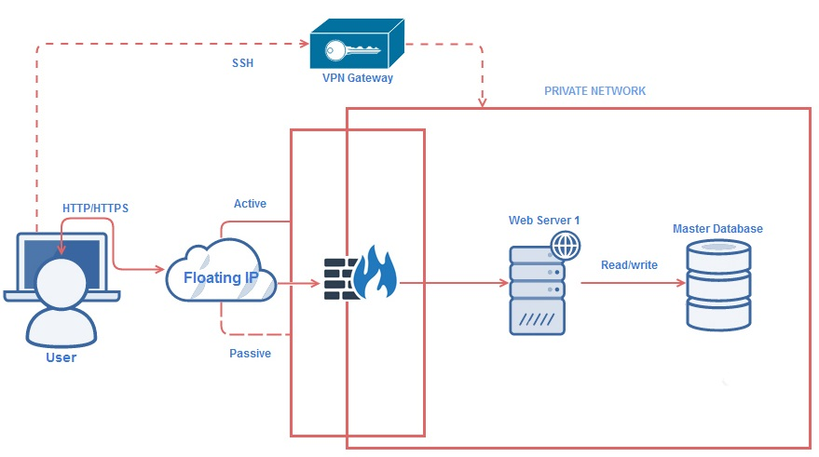

Data Migration
Data migration is an important activity in almost every organization arising from constant endeavor to improve data storage and retrieval process. However, when existing data is migrated to a new target application, it can become apparent that it contains inaccuracies, unknowns, and redundant and duplicate material. And although the data in the source system may be perfectly adequate for its current use, it may be wholly inadequate, in terms of content and structure, for the objectives of the target system.

There will be proper checks and validation during data migration process and 100% data will be migrated.

Data Migration Process
At a high level, the data migration process involves the following steps:

Scope
All the data objects and data (Master data as well as transactional data) need to be migrated from existing database.

Data Mapping
Data Mapping from source to target objects will be done to migrate the data to new system. Understanding of all the three databases is required before migration.

Option Selection
Data migration will be done using migration tools followed by data migration scripts and programs.

Migration
Perform data migration to the destination system using selected solution Perform data migration to the destination system using selected solution. 100% data will be migrated of the applications. Though data cleansing will be required and during that process some records may be discarded with department concurrence.

Following steps will be performed for migration

- Backup of existing databases will be taken and the date of the backup will be treated as cut-off date.
- Complete testing of the application will be performed with new integrated database.
- Data will be migrated & validated on daily basis till the final switch over.

Validation
Perform audits, validations and acceptance test to validate and certify data at destination.

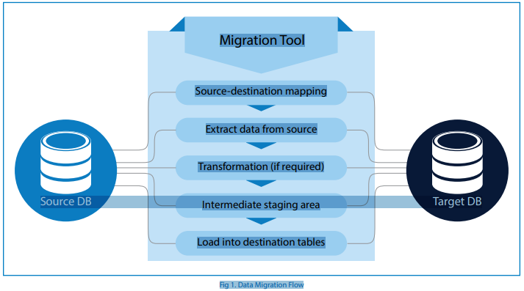

Data Validation Process

Data Integrity
We will ensure overall accuracy, completeness, and consistency of data.

Data Correctness
We will ensure that whatever data has been migrated should be correct and match with legacy data.

Zero Data Loss
We will ensure the migration of complete data. No data loss will happen during migration.

Proper Functioning of Application
Smooth function of application will be ensured with the new database / schema after data migration.

Performance Optimization
Application and database performance will be optimized as compared to legacy application / database.

Deployment Environment

Development Environment
# | Description | Details
1 | Hardware Requirement
2 | Software Requirement
3 | Third Party Tool (if any)

Staging / Test Environment
# | Description | Details
1 | Hardware Requirement
2 | Software Requirement
3 | Third Party Tool (if any)

Production Environment
# | Description | Details
1 | Hardware Requirement
2 | Software Requirement
3 | Third Party Tool (if any)

Escalation Matrix

Level | Name | Designation | Contact Details  (Phone / Email)
First
Second
Third

Common Functionalities
This Appendix describes the various general functionalities that will be implemented throughout the application following industry best practices.

System Administration
- System Administrator can activate, deactivate user.
- Can add role, modify role
- Can add, delete and modify values in master tables
- Can authorize users to view / block documents

Role Based Access
Application will allow role based access thereby restricting system access to authorize user only. The permission to perform certain operations is assigned to specific roles and thus system will show features / options specific to the concerned role only.

Dashboards
It is a business intelligence function which will allow higher management and users to have at-a-glance perspective on the current status of the petitions in the context of predetermined metrics. It will help keeping management at the top of vital stats and visualize the current status and gaps that require urgent attention.

SMS and Email
- The system will facilitate notification of status of application through SMS and email of stakeholder in automated mode.
- Admin users can control the notification and messaging time through master data management

Trap / Audit Trail
The objective is to maintain all the important information / transaction so as to keep record of system usage. Functionality will be provided to view this changes / audit trail based on various conditions like
- By User Name
- Date (period)
- Transaction id

Logs
An application log will be generated to file events that are logged by a software application. It will contain errors, informational events and warnings. The log files will reveal message flow issues and application problems. It will also contain information about user and system actions that have occurred. Logged events typically includes
- Warnings about low disk space
- An operation that has been carried out.
- Any significant problems – error events, that prevent application from starting
- Severe errors that cause premature termination. Expect these to be immediately visible on a status console
- Other runtime errors or unexpected conditions. Expect these to be immediately visible on a status console.

Secure Data Transmission
Security will be the prime thrust area and system would not allow any leakage of essential and confidential information. It will provide a secure role based access to User’s based on their assigned access rights. Secure online data entries from stakeholders will serve as data source for all reports and would allow stakeholders to monitor the progress at every level.

Security
Security audit of the application will be done for checking the OWASP from CERT-In/ empanelled agencies.
- Safe to host certificate for website and application.
- Application server security
- Protection from virus/worm attacks
- Data security
- Application level security
- Free from OWASP Top 10 vulnerabilities.

Security Standards
Velocis will incorporate the various security standards during the application development as mentioned below

Security Standards
User Authentication
Audit Trail Management
Encryption Technique
CERT-In
3Level verification

Storing Passwords:
- Hashing A Password Using Bcrypt
- Verifying A Password Against A Hash
- Checking If A Password Needs To Be Rehashed

Authenticating Users:
- Determining If A User Is Authenticated
- Authenticating A User And "Remembering" Them
- Determining If User Authed Via Remember
- Authenticating A User With Conditions
- Accessing The Logged In User
- Validating User Credentials Without Login
- Logging A User In For A Single Request

Protecting Routes:
- CSRF Protection
- Inserting CSRF Token Into Form
- Validate The Submitted CSRF Token

HTTP Basic Authentication:
- Protecting A Route With HTTP Basic
- Setting Up A Stateless HTTP Basic Filter

Password Reminders & Reset:
- Model & Table
- Password Reminder Controller
- Password Validation

Encryption:
- Encrypting A Value
- Decrypting A Value
- Setting The Cipher & Mode

Authentication Drivers:
- Database authentication drivers
- Eloquent authentication driver
- Application Security

Application Security
The following identifies each of the OWASP Top 10 Web Application Security Risks, and offers solutions and best practices to prevent or remediate them.
A6 Sensitive Data Exposure
A7 Insufficient Attack Protection
A8 Cross-Site Request Forgery (CSRF)
A9 Using Components with Known Vulnerabilities
A10 Under protected APIs
A5 Security Misconfiguration
A4 Broken Access Control
A3 Cross-Site Scripting (XSS)
A2 Broken Authentication and Session Management
A1 Injection
OWASP Web Top 10

Injection

Injection flaws, such as SQL injection, LDAP injection, and CRLF injection, occur when an attacker sends untrusted data to an interpreter that is executed as a command without proper authorization.
* Application security testing can easily detect injection flaws. Developers should use parameterized queries when coding to prevent injection flaws.

Broken Authentication and Session Management

Incorrectly configured user and session authentication could allow attackers to compromise passwords, keys, or session tokens, or take control of users’ accounts to assume their identities.
* Multi-factor authentication, such as FIDO or dedicated apps, reduces the risk of compromised accounts.

Sensitive Data Exposure

Applications and APIs that don’t properly protect sensitive data such as financial data, usernames and passwords, or health information, could enable attackers to access such information to commit fraud or steal identities.
* Encryption of data at rest and in transit can help you comply with data protection regulations.

XML External Entity

Poorly configured XML processors evaluate external entity references within XML documents. Attackers can use external entities for attacks including remote code execution, and to disclose internal files and SMB file shares.
* Static application security testing (SAST) can discover this issue by inspecting dependencies and configuration.

Broken Access Control

Improperly configured or missing restrictions on authenticated users allow them to access unauthorized functionality or data, such as accessing other users’ accounts, viewing sensitive documents, and modifying data and access rights.
* Penetration testing is essential for detecting non-functional access controls; other testing methods only detect where access controls are missing.

Security Misconfiguration

This risk refers to improper implementation of controls intended to keep application data safe, such as misconfiguration of security headers, error messages containing sensitive information (information leakage), and not patching or upgrading systems, frameworks, and components.
* Dynamic application security testing (DAST) can detect misconfigurations, such as leaky APIs.

Cross-Site Scripting

Cross-site scripting (XSS) flaws give attackers the capability to inject client-side scripts into the application, for example, to redirect users to malicious websites.
* Developer training complements security testing to help programmers prevent cross-site scripting with best coding best practices, such as encoding data and input validation.

Insecure deserialization

Insecure deserialization flaws can enable an attacker to execute code in the application remotely, tamper or delete serialized (written to disk) objects, conduct injection attacks, and elevate privileges.
* Application security tools can detect deserialization flaws but penetration testing is frequently needed to validate the problem.

Using Components with Known Vulnerabilities

Developers frequently don’t know which open source and third-party components are in their applications, making it difficult to update components when new vulnerabilities are discovered. Attackers can exploit an insecure component to take over the server or steal sensitive data.
* Software composition analysis conducted at the same time as static analysis can identify insecure versions of components.

Insufficient Logging and Monitoring

The time to detect a breach is frequently measured in weeks or months. Insufficient logging and ineffective integration with security incident response systems allow attackers to pivot to other systems and maintain persistent threats.
* Think like an attacker and use pen testing to find out if you have sufficient monitoring; examine your logs after pen testing.

Testing
Testing will be carried out module wise by Velocis and stakeholders. Test results will be verified and discussed with CONCOR before incorporating the changes suggested by them.

Security testing will be carried out by Cert-In and NIC before deployment on the production server for any vulnerability. Security testing is of two types – static analysis and dynamic analysis.

Dynamic analysis involves performing tests on a running instance of an application and is also known as black box testing. The security test will involve sending requests to the application and observing the responses to see if there was any indication that security vulnerability may be present. Automated tools are used by Auditing Agency for this testing. These tools are good for finding much common vulnerability such as SQL injection and cross-site scripting (XSS).

Static analysis involves reviewing application assets like source code, configuration files and so on when they are static -- or at rest. This is also known as source code analysis or white box testing.

Training
To train the stakeholders, administrator and users of this application training and workshops will be conducted as and when required for the same.

Sign-Off

Project Acceptance Criteria
[The sign off & Acceptance process for the project deliverables are illustrated in this subsection]

Project Milestone
# | Milestone Name
1
2
3

Document Sign-Off
# | Document Name | Signed By | Version | Date  (dd/mm/yy)
1
2
3

Annexure

Annexure A: References
Suggestion

Annexure B: Changes/Suggestion
Suggestion

